CREATE DATABASE TravelAgency

CREATE TABLE Employees_dim

(ID_employee INT IDENTITY (1,1) PRIMARY KEY,

FirstName NVARCHAR(50) NOT NULL,

LastName NVARCHAR(50) NOT NULL,

Gender NVARCHAR(10) NOT NULL CHECK (Gender LIKE 'Female' OR Gender LIKE 'Male'),

TelNumber NVARCHAR(20) UNIQUE,

Email NVARCHAR(100),

DateEmployment DATE NOT NULL,

DateDismiss DATE NOT NULL

)

CREATE TABLE Customers_dim

(ID_customer INT IDENTITY(1,1) PRIMARY KEY,

FirstName NVARCHAR(50) NOT NULL,

LastName NVARCHAR(50) NOT NULL,

PassportNumber NVARCHAR(50) NOT NULL UNIQUE,

Gender NVARCHAR(10) NOT NULL CHECK (Gender LIKE 'Female' OR Gender LIKE'Male'),

DateOfBirth DATE NOT NULL,

TelNumber NVARCHAR(20) UNIQUE

)

CREATE TABLE Tours_dim

(ID_tour INT IDENTITY(1,1) PRIMARY KEY,

Name NVARCHAR(50) NOT NULL,

Country NVARCHAR(50) NOT NULL,

Hotel NVARCHAR(50) NOT NULL,

HotelStars INT CHECK (HotelStars BETWEEN 1 AND 5) NOT NULL,

Address NVARCHAR(100),

DurationDays INT,

Price MONEY

)

CREATE TABLE Operators_dim

(ID_operator INT IDENTITY(1,1) PRIMARY KEY,

Name NVARCHAR(50) NOT NULL,

TransportType NVARCHAR(50) NOT NULL,

Address NVARCHAR(100),

TelNumber NVARCHAR(20) UNIQUE,

Email NVARCHAR(100)

)

CREATE TABLE Orders_fct

(ID_order INT IDENTITY(1,1) PRIMARY KEY,

ID_customer INT,

ID_employee INT,

ID_operator INT,

ID_tour INT,

StartDate DATE,

Discount DEC (3,1) CHECK (Discount<100 AND Discount>=0),

CONSTRAINT FK_Customer FOREIGN KEY (ID_customer) REFERENCES Customers_dim(ID_customer)

ON UPDATE CASCADE

ON DELETE CASCADE,

CONSTRAINT FK_Employee FOREIGN KEY (ID_employee) REFERENCES Employees_dim(ID_employee)

ON UPDATE CASCADE

ON DELETE CASCADE,

CONSTRAINT FK_Operator FOREIGN KEY (ID_operator) REFERENCES Operators_dim(ID_operator)

ON UPDATE CASCADE

ON DELETE CASCADE,

CONSTRAINT FK_Tour FOREIGN KEY (ID_tour) REFERENCES Tours_dim(ID_tour)

ON UPDATE CASCADE

ON DELETE CASCADE

)

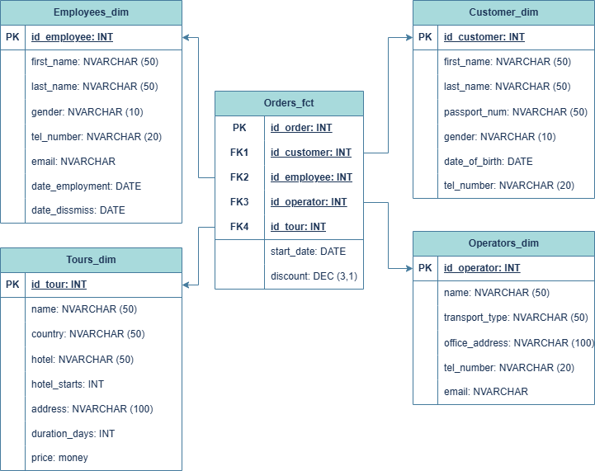

2)

WITH random_names

AS ( SELECT DISTINCT 'Name_' || md5(random()::text) AS first_name,

'Surname_' || md5(random()::text) AS last_name

FROM generate_series(1, 1000000)

)

INSERT INTO persons (first_name, last_name)

SELECT first_name, last_name

FROM random_names

CREATE TABLE people

( id SERIAL PRIMARY KEY,

first_name TEXT NOT NULL,

last_name TEXT NOT NULL );

INSERT INTO people (first_name, last_name)

SELECT (ARRAY['Алексей', 'Дмитрий', 'Иван', 'Петр', 'Михаил', 'Сергей', 'Андрей', 'Николай', 'Владимир', 'Артем'])[floor(random() * 10) + 1], (ARRAY['Иванов', 'Петров', 'Сидоров', 'Кузнецов', 'Смирнов', 'Васильев', 'Михайлов', 'Федоров', 'Сергеев', 'Попов'])[floor(random() * 10) + 1]

FROM generate_series(1, 1000000);